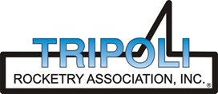
Tripoli Motor Testing Division
223 NC Highway 54 West
Chapel Hill, NC 27514
(919) 357 5681 (c)
April 30, 2023

Gary Rosenfield
RCS Rocket Motor Components, Inc.
2113 West 850 North Street
Cedar City, UT 84721

Dear Mr. Rosenfield,

The Aerotech N4000W-PS motor was tested on April 29, 2023 and is in compliance with NFPA 1125. The motor is certified for hobby rocketry use by the members of the Tripoli Rocketry Association and all approving organizations with reciprocal certifying agreements.

Motor Manufacturer Aerotech Division, RCS Rocket Motor Components
Manufacturer’s Designation N4000W-PS [RMS, 98/20480 case]
Propellant White Lightning
TMT Nomenclature 18,184 N3906

Diameter 3.878” 98.49 mm
Overall Length 56.406” 1432.7 mm
Length Inside 53.969” 1370.8 mm
Length Outside 2.438” 61.91 mm

Loaded Mass 36.10 lb 16,374.7 g
Propellant Mass 21.605 lb* 9,800 g*
Burnout Mass 14.165 lb 6,425.1 g
* data provided by manufacturer

Burn time 4.747, 4.563 sec

Total Impulse 4087.9 lbf.s 18,183.8 N.s
Max Impulse 1213.6 lbf 5398.3 N
Average Impulse 878.11 lbf 3905.9 N
Number of Motors Tested 2

Nominal Measured
Delay Time Data n.a. n.a.

Casing Temp. [NFPA 1125 7.4.1] Passed

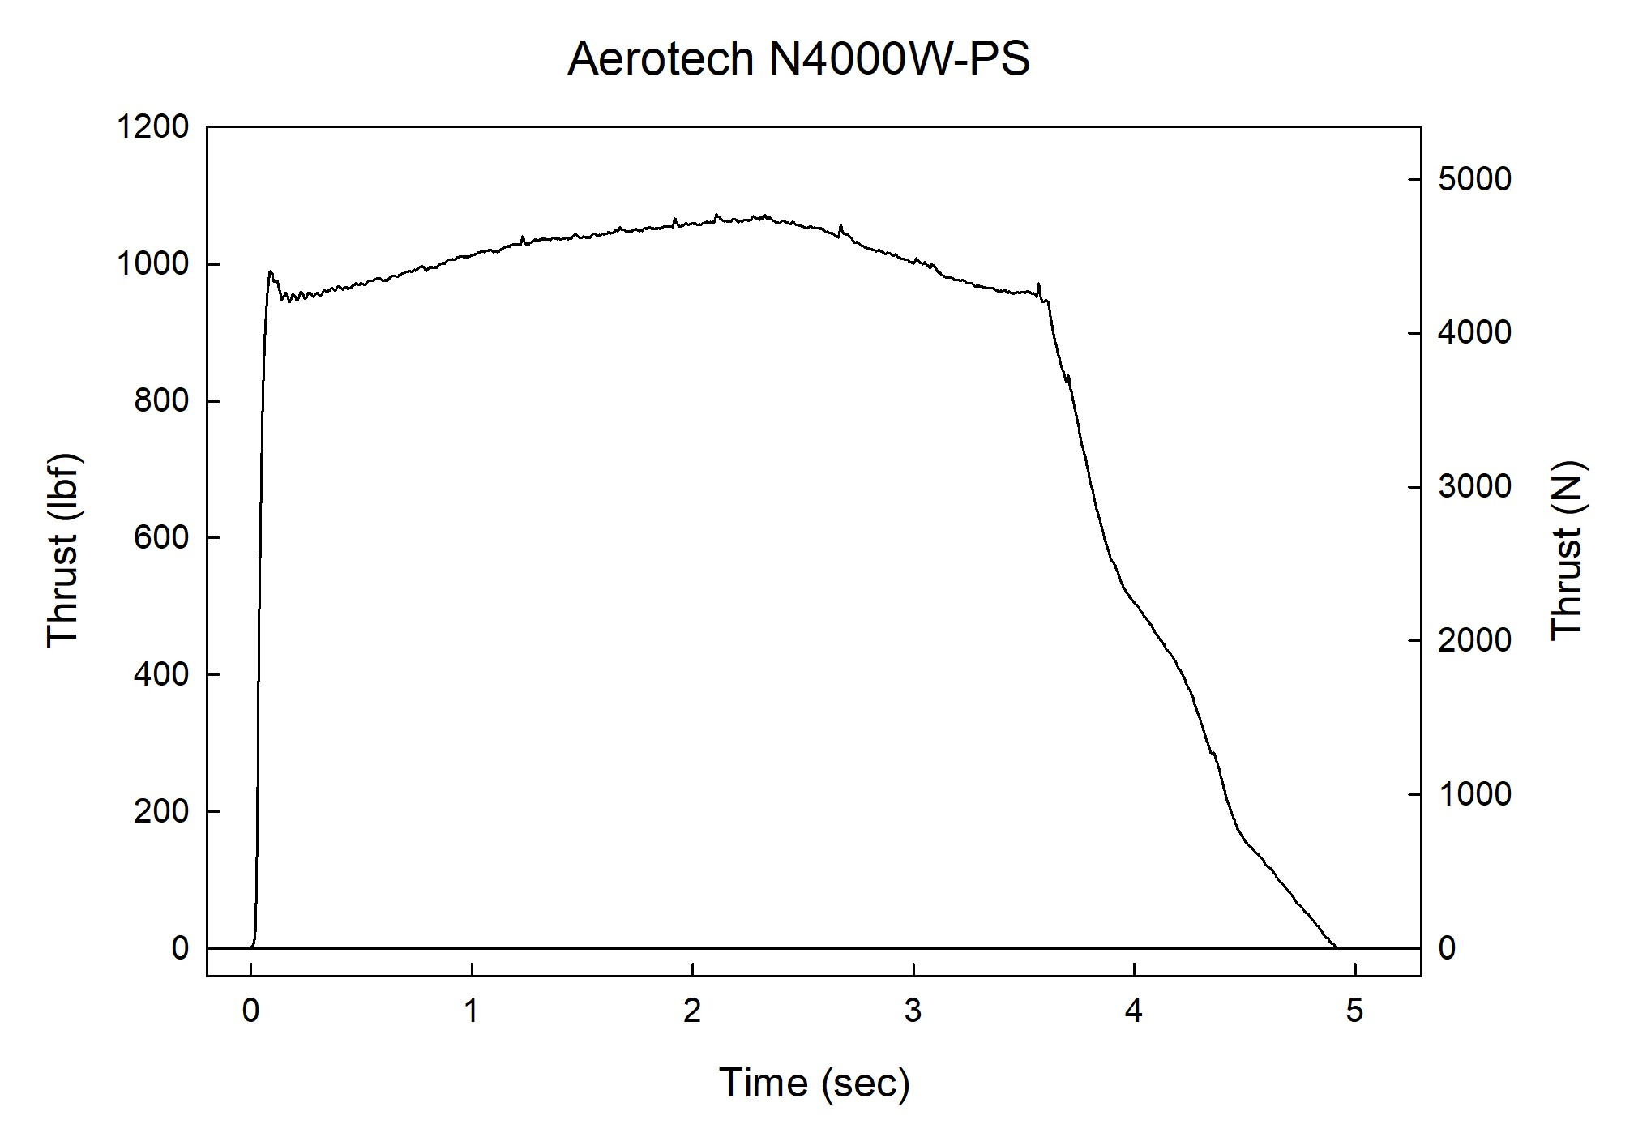

Sincerely,

Alan C. Whitmore
Chair, Tripoli Motor Testing

